

**ASHAR 14,1426 BS**

**VoL XXXII:No.160**

**REGD. NO: DA 781**

**DHAKA FRIDAY MAY 28, 2024**

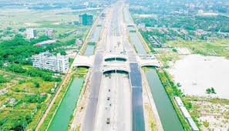

**TK 199CR DEFAULTED LOAN**

BB allows

‘launderer’ to

Reschedule it

Also lets the lending bank waive

Tk 7lcr in interest

AKM ZAMIR UDDIN

Major development work at the capital’s 300-feet Purbachal Road is underway. The authorities are building an eight-line expressway to connect Kuril with Kanchan Bridge via Purbachal.

PHOTO: **TASHIN HASSAN**

In a gross violation of its own rules, the central bank has allowed an alleged money launderer to reschedule a defaulted loan of taka 199 crores was taken from Bangladesh Commerce Bank Ltd, through forged documents.

PRESSURE ON FOREX RESERVES

**Govt exploring loan of**

**Up to $4.5b from the IMF**

Bangladesh Bank also permitted the BCBL to waive interest to the tune of Tk 71 crore on the defaulted loan of SB Exim owned by the alleged money launder, Shahjahan Bablu.

**No bank is allowed to reschedule any defaulted loans that have been secured through forgery**

**REJAUL KARIM and ASIFUR RAHIM**

Though Bablu has not shipped any goods abroad, he sold the lake export bills to the bank.

Which is sufficient to cover about five months’ import bill. Typically, the World Bank and the IMF prescribe an import cover of three months but in times of economic uncertainly, they advise keeping sufficient reserves to meet 8 9 imports.how they can come yo visit here

Going forward, even though

Which is sufficient to cover about five months’ import bill. Typically, tan import cover of three months but in times of economic uncertainly, they advise keeping sufficient reserves to meet 8 9 imports.

Going forward, even though

*(SEE PAGE 2 COL 3)*

As a precautionary move, Bangladesh has started talks with the International Monetary Fund about taking a loan of 4.5 million to show the precarious foreign currency

Yesterday, foreign currency reserves stood at $41.7 bill

The kinder later created a loan against

the payments of the borrower as it didn’t receive the money from foreign.

*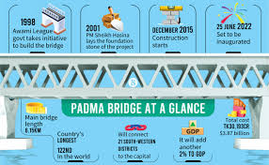(SEE PAGE 2 COL 1)*

**



**ZILQUAQ 27, 1443 HIJRI**

www.thedailystar.net

**16 PAGES PLUS LIFESTYLE: TK 12.00**

Children 5-12 get Pfizer jabs

2101 new cases recorded

STAFF CORRESPONDENT

Amid the rising trend of novel coronavirus transmission, the government will inoculate children aged between 5 to 12. Prof. Meerjada Sabrina Flora additional director general of the health directorate, said yesterday.

For this, the children need to be registered via [www.surokkha.gov.bd](http://www.surokkha.gov.bd) using the birth registration certificates.

Prof. Flora said, “For those who don’t have birth registration certificates, I request their guardians to do it as early as possible”.

She, however, did not mention the date of starting the campaign. According to health officials, children of this age will

*(SEE PAGE 5 COL 1)*